ANES 500 Chapter 11 Group Assignment Fall 2020_2021

Names: ___________________ ____________________ __________________

General Instructions
Work with the other members of your group and provide suitable responses for the problems shown below. Please work on your own if your schedule does not permit you to work with the other members of your group. The assignment is to be completed and returned by 11:30 pm EDT on Monday, November 16, 2020. Where applicable, show your work to receive full credit. Late assignments will be assessed a penalty of 5% of the overall grade per day late.

How to Return This Assignment
You may upload the document to the drop box in Canvas as a Word file, a pdf file, a jpeg file, a scanned file, etc. The document may also be returned as an email attachment in canvas. If the file is too large, try compressing it using free services such as wecompress.com. Do not return the file using my outlook email. For those who save each page of the assignment as a pdf or image file, you may combine them into one document as follows:

- Locate the files in Windows File Explorer.
- Right click on the first file.
- Choose “Combine Supported Files in Acrobat…” A new dialog box will pop up, but you may have to minimize other files to see it.
- Drag the files from Explorer into this box.
- If necessary, change the order of the files using “Move Up” or “Move Down.”
- Click on “Combine Files.” You will be prompted for a file name.
If all else fails, you may fax the document to the attention of Dr. Farrell using Fax: 407-303-8136. Please ensure that your work is legible, and your file is complete before sending.

ANES 500 Chapter 11 Group Assignment Fall 2020_2021

Names: ___________________ ____________________ __________________

- Draw condensed structural formulas for the following compounds: (3 pts)

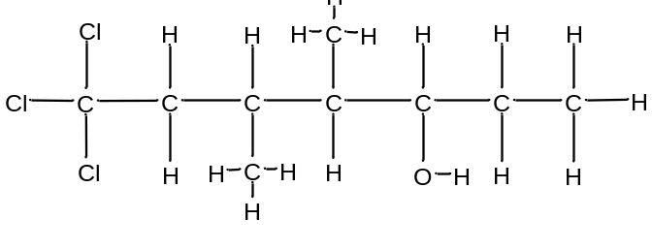

- Draw the skeletal structure for each of the following compounds: (3 pts)

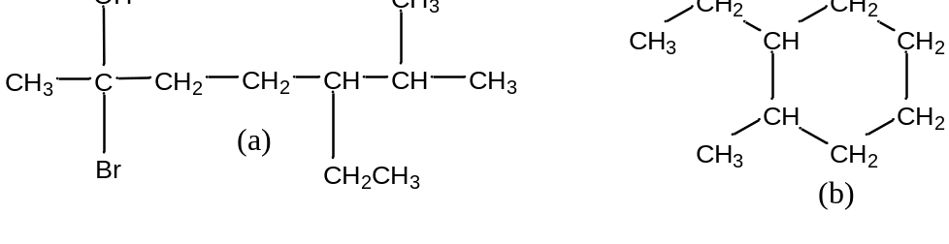

- Draw a condensed structure for each of the following compounds: (3 pts)
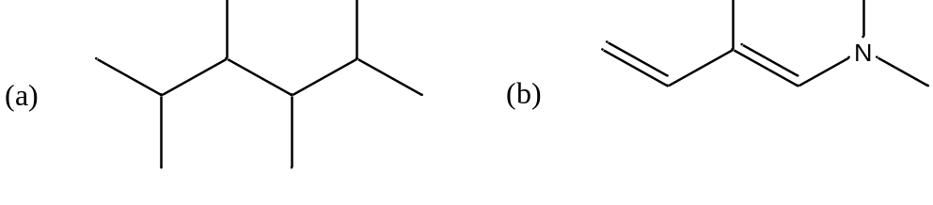

- Which atoms in the following molecule violate the octet rule? (3 pts)
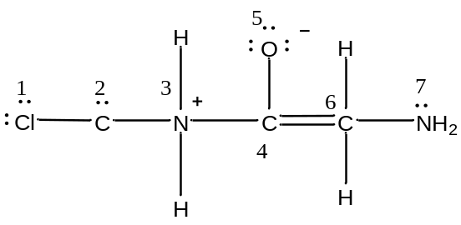

- Identify the hydrocarbons from the following compounds and classify them as alkanes, alkenes or alkynes. (3 pts)
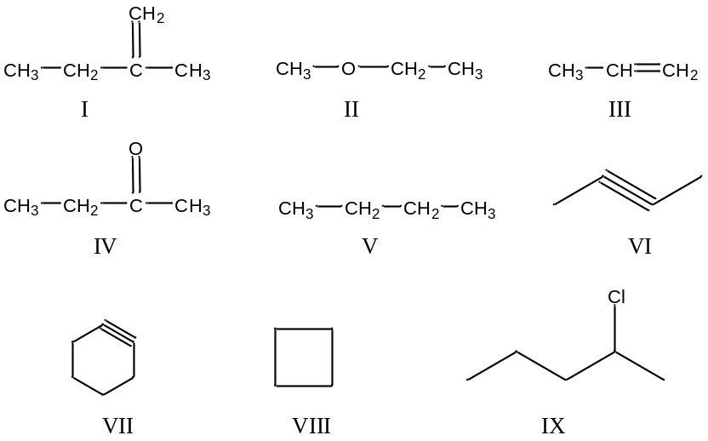

- Identify each of the functional groups shown below. (4 pts)

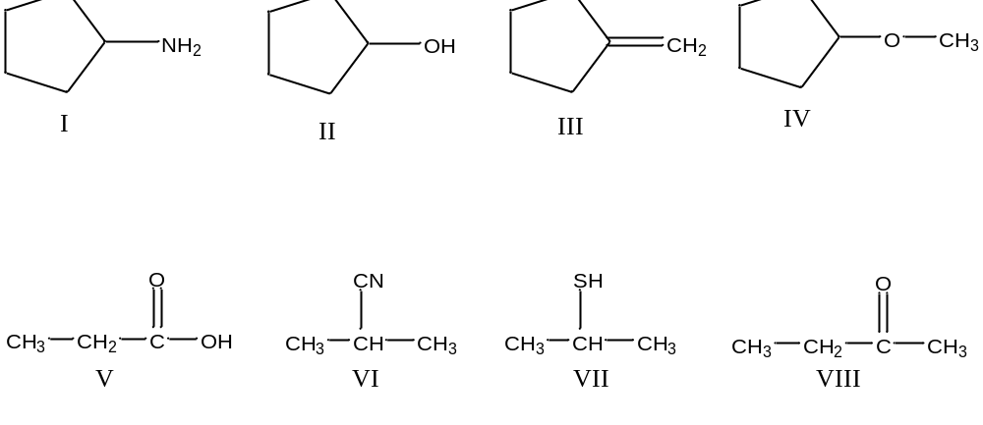

- Classify the following as primary, secondary, or tertiary alcohols: (3 pts)

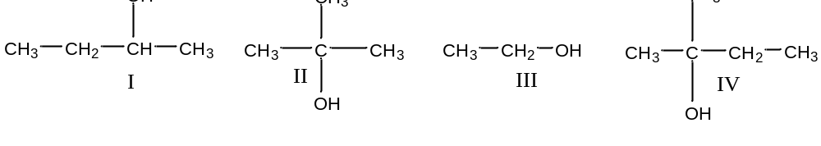

- Classify the following as primary, secondary, or tertiary amines: (3 pts)

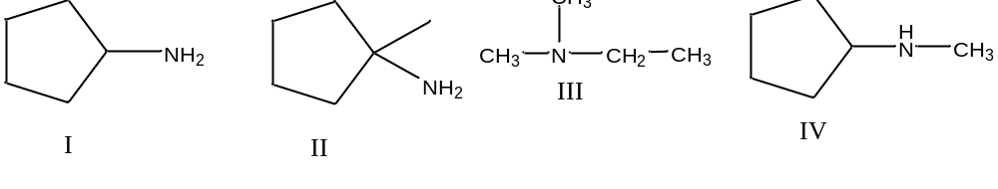

- Which compound in each pair is more soluble in benzene? (3 pts)
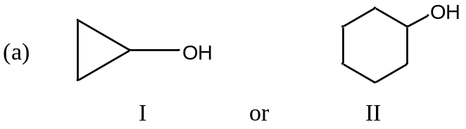

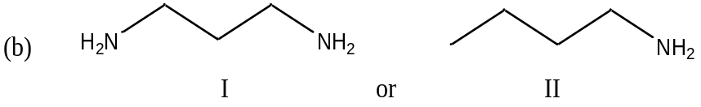

- Which compound in each pair is more soluble in water? (3 pts)

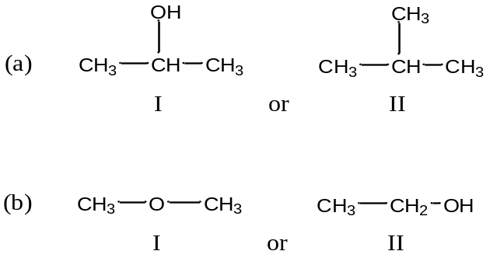

- Give the IUPAC name for the following organic compounds: (4 pts)
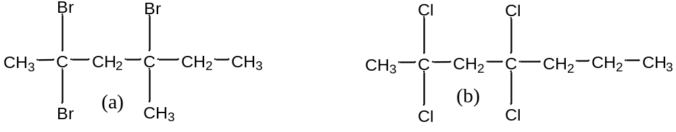

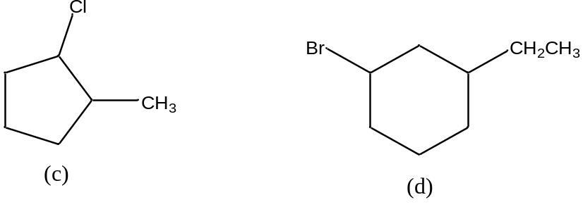
- Draw structural formulas for the following compounds: (4 pts)

- Classify the following compounds as cis or trans isomers. (4 pts)

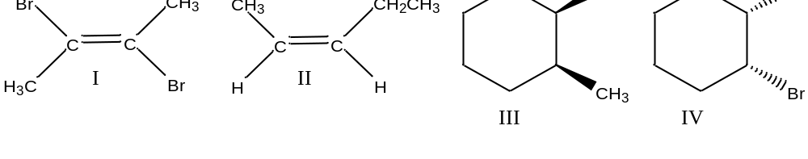

- Draw structural formulas for the following Cis-trans alkenes. (6 pts)

- Trans-3-Heptene (b) Cis-3-Heptene

- Draw the major organic product for each of the following reactions. (6 pts)
